## **Question 1: DNN Architecture Design**

### **Python Code**

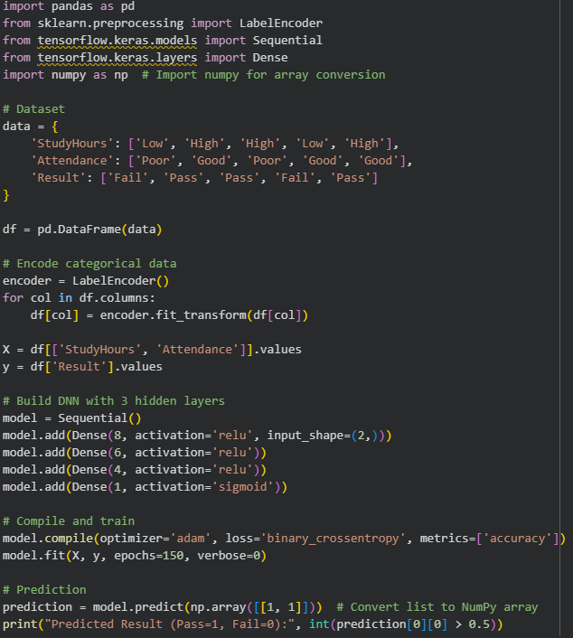  
  
**OUTPUT**



## **Question 2: Activation Function Analysis**

### **Python Code for Model A (ReLU)**

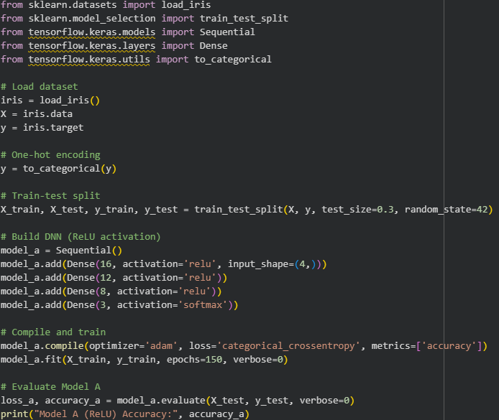  
**OUTPUT**



### **Python Code for Model B (tanh)**

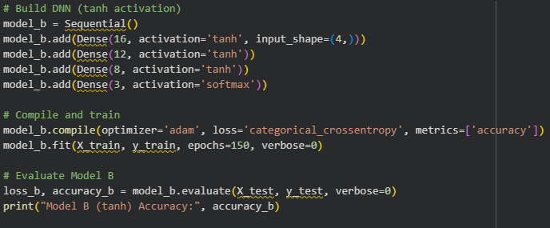

**OUTPUT**



## **Question 3: Hyperparameter Tuning in DNN**

## **Python Code**

**OUTPUT**

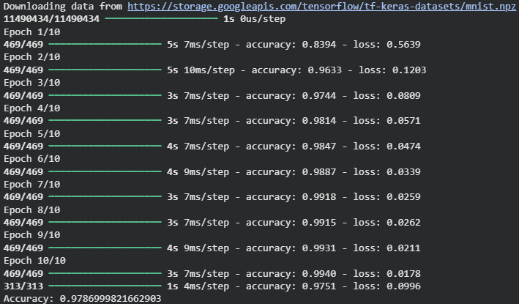

## **Question 4: Overfitting and Regularization**

### **Python Code with Early Stopping (Regularization)**

**OUTPUT**

